***HOW TO BOOST YOUR WRITING SCORE***

1. **Vary your Sentence Length**

Once you know the different types of sentences, you should practice using them. The most difficult one is the compound-complex sentence, but even if you don’t know that, you can still get a good score with **a mix of simple, compound, and complex sentences**. The key is varying the length and type of sentence so it sounds natural. Look at this example:

*Firstly, children watch too much TV. It’s bad for their health. It can make them addicted. They will spend too much time indoors. This can make them fat.*

The sentences are all short and could easily be mixed together into more interesting patterns:

*Firstly, children watch too much TV, which is bad for their health. This habit can cause them to become addicted, resulting in them spending too much time indoors and thus getting fat.*

1. **Remember Collocations**

Students preparing for the IELTS exam always want to study lots of vocabulary. This is understandable as vocabulary is important for understanding and making yourself understood. However, knowing a word’s meaning is very different from being able to use it. **Learn a word in context and you will be able to apply it more easily. When you are learning vocabulary, pay attention to what words commonly go together.**

Example:

***Verb + thought:***

*Spare a thought*

Spare a thought for all those who are homeless on a cold night like this.

*Hear one’s thought*

Have you given the new proposal any thought yet? Were keen to hear your thought

*One’s thought goes out to somebody/something*

Our thoughts go out to all those families who lost relatives in the disaster.

*The thought occurs to someone*

The thought just occurs to me that it’s mum’s birthday tomorrow and we haven’t got her a card.

*Gather one’s thought*  
The President was taken aback by the question and took a minute to gather his thoughts.

***Noun + preposition + thought:***

*great deal of thought*  
Shirley doesn’t devote a great deal of thought to her appearance.

*freedom of thought*  
*Some places don’t encourage freedom of thought.*

*school of thought*  
One school of thought contends that modern man originated in Central Africa.

*train of thought*  
Sorry, where was I? I’ve lost my train of thought.

**Some common collocations in writing task 2**

**1-To play/have a(n) important/key/vital/crucial role in (doing) sth:**  đóng vai trò quan trọng trong việc...

§  Advancements in social networks have played a vital role in making people closer.

**2-To make significant/substantial/valuable/ great/outstanding contribution to sth:** góp phần đáng kể vào...

§  International assistance has made a significant contribution to the implementation of the rights of women in Africa.

**3-To solve the problem:** giải quyết vấn đề

§  We must solve this problem before it gets worse.

**4-To be key factors influencing something:** là nhân tố chủ chốt ảnh hưởng việc gì

§  The easy access of addictive drugs is the key factors influencing drug addiction.

**5-To reap the benefits (of sth) – gain benefit from something/ make the most of something:** có được lợi ích từ...

§  During wartime, the US reaped the benefits of providing weapons for the belligerent countries.

**6- To be a contributing factor:  to be one of the main causes of sth:** là yếu tố góp phần vào...

§  Poverty has been a contributing factor to the increasing child malnutrition in underdeveloped societies.

**7-To contribute to sth:** góp phần vào...

§  Downgraded roads contribute to the flooded condition of several areas in Vietnam during rainy season.

**8-To gain/derive benefit (from sth):** có lợi từ...

§  University students derive a great deal of benefits from attending extracurricular activities.

**9-To have a right to do sth = to be entitled to do sth:** được quyền/ đủ tư cách

§  Employees who work overtime will be entitled to extra pay.

**10-To benefit greatly/enormously/considerably … from sth:** được lợi đáng kể

§  That company has benefited greatly from its innovative sales strategies.

**11-To have/enjoy/achieve a huge/great success in doing sth:** đạt được thành công to lớn trong việc...

§  Walt Disney has achieved a great success in making cartoons and live-action movies.

**12- To launch a full-scale investigation into sth:** tiến hành điều tra toàn diện vào việc gì

§  The government launched a full-scale investigation into the financial records of ABC company last month.

**13- To meet the need of/demand:** đáp ứng nhu cầu

§  In order to meet the increasing need of social welfare, British Parliament decided to raise the tax rate.

**14-To fulfill a role/duty/function/ an aim/a goal/an objective/dream/ambition/hope:** hoàn thành lời hứa/ vai trò/ nghĩa vụ/ mục tiêu/ hi vọng...

§  Having such a high-paid salary has fulfilled his lifelong dream.

**15-To fulfill a requirement/condition/obligation:** hoàn thành nghĩa vụ

§  All the Korean male citizens must fulfill their military obligation when they reach a certain age.

**16-To fulfill a promise/pledge = to keep a promise:** giữ lời/ hoàn thành lời hứa

§  He fulfilled his promise to get flying colors in the final exams.

**17-To satisfy sb’s needs/demands/desires/requirements:** thỏa mãn nhu cầu

§  Facebook constantly updates its app in order to satisfy public demands.

**18-To have/gain knowledge/understanding of sth:**  đạt được kiến thức/ hiểu biết về...

§  She spent the whole weekend reading several books to gain knowledge of women liberation in the US.

**19- To have/make common cause (with/against):** đoàn kết/ chống lại

§  The rebel parties made common cause with one another to overthrow the regime.

**20- To cause somebody to do something:** khiến ai đó làm gì

§  The soft music caused us to fall asleep.

21. ........

**Link to practice collocation**: <http://www.drillpal.com/drill-search/collocation>

Collocation Patterns

There are quite a few patterns such as:

* **Verb + Noun**
* **Verb + Adverb**
* **Adjective + Noun**
* **Adverb + Adjective**
* **Noun + Noun**
* **Collocations with ‘have’ or ‘take’**

Verb Noun collocations

a) It was his 21st birthday so he decided to **throw a party.**  
b) The student**raised a question** about the topic in class.  
c) The teacher **paid** him **a compliment** about his well written IELTS essays.  
d) She was late for work so she **made an excuse** about the train being delayed.  
e) The government is **giving priority** to the issue of air quality in cities.  
f) I **made an appointment** to see the dentist.  
g) The student **made an effort** to improve his essay writing.

Verb Adverb collocations

a) The customer **complained bitterly** about the terrible service.  
b) The guests were **welcomed warmly** when they arrived at the party.  
c) She **spoke loudly** over the phone because the signal wasn’t very good.  
d) He **smiled proudly** when he got his IELTS exam results.  
e) He **apologised profusely** after bumping into the man and spilling his drink.  
f) She is a very gentle person who **speaks softly**.

Adjective Noun collocations

a) The boy shows a **keen interest** in going to University and becoming a Doctor.  
b) We had a **brief chat** about our travel plans next week.  
c) There was **heavy snow** overnight, the roads were all blocked.  
d) I was given **invaluable advice** by the teacher about doing the reading test.  
e) He suggested going to the beach. It was a **fantastic idea** so we all decided to go.  
f) There is a **strong possibility** that the climate will get warmer over the next two decades.

Adverb Adjective collocations

a) I was **utterly shocked** by his bad behaviour.  
b) She is **totally satisfied** with her Band 8 score in IELTS  
c) It is **incredibly stupid** to drink and drive.  
d) The weather is **rather cold** for this time of year.  
e) The new laws about internet privacy are **pretty worrying**.  
f) I’m **extremely interested** in getting a Band 9 in IELTS.

Noun Noun collocations

a) There was **a** **ceasefire agreement** by the rebel groups.  
b) I bought **a** **loaf of bread** and  **a** **can of coke.**  
c) He bought **a round of drinks** for his friends  
d) He got **a round of applause** after his performance  
e) They work in **the** **service industry**.  
f) You need **a building permit** to build a house.

Collocations with ‘Have’ or ‘Take’

In British English the word **‘have’** is quite popular, for example: **have a bath, have a look,** **have a break**. In American English the word **‘take’** is often used such as : **take a bath, take a vacation, take a look.**

* Have a bath – Take a bath
* Have a drink
* Have a look – Take a look
* Have lunch
* Have fun
* Have a rest – Take a rest
* Have a holiday – Take a vacation
* Have a seat – Take a seat
* Have a haircut
* Have a wash
* Have a shave
* Have a nice day
* Have something to eat
* Have a laugh
* Have a tough time

So you need to now take action (take action – verb noun collocation !)  and start your IELTS collocations notebook, remember to make sentences and use them in speaking.

Collocations exercise

What collocations fit into the sentences below?. Try it first then check your answers.

1. Mr Smith was __________ **welcomed** when he arrived at the conference.  
2. There was **_______ rain** all night, the streets were flooded.  
3.  Many people **________ questions** about the governments new immigration policy.  
4. Most developed countries are ________ **priority** to the implementation of renewable energy.  
5. We **_______ a reservation** for a room in the hotel.  
6. She **_________ profusely** for arriving late for the meeting.  
7. I needed to**_______ a haircut** so I went to the barbers.  
8. Hello Mr Smith, please **______ a seat**.  
9. I was given**___________ advice** about preparing for IELTS writing task 2.  
10. It is an **_________ silly** thing to do, driving while using a smartphone.

1. **Using a more academic word and phrase**

**\* Avoid using *really, so, a lot, very***

In IELTS writing, you need to write an essay, using “academic” language. So your goal should be to be *reasonably*formal/academic. To do so, you should not use imprecise language like ***really, so, a lot, very, etc***

Examples:

1. Many IELTS candidates think that achieving Band 8.0 in IELTS is ***very hard***.

==> Use a stronger word: Many IELTS candidates think that achieving Band 8.0 in IELTS is **difficult**

***Very good*** ==> top-notch, splendid, terrific, excellent, magnificent, fabulous, outstanding, etc

***Very bad*** ==> horrible, terrible, outrageous, distressing, awful, etc

***Very delicious*** ==> appetizing, delectable, flavorful, scrumptious, enjoyable, palatable, etc

1. Robot-driven car is **really controversial**

==> Robot-driven car is **controversial**

1. **A lot of** IELTS learners share their great tips on IELTS writing, speaking on IELTS Material website.

==> **Many/A great number of/ A multitude of** IELTS learners……

***\* Verbs:***

For written academic style, the preferred choice is a **single verb** whenever possible.

E.g. Reserchers *looked a*t the way strain *builds up* around a fault.

- Reserchers ***observed*** the way strain ***accumulates*** around a fault.

**Exercise:**

1. experts System can *help out* the user in the diagnosis of problem.
2. This program was *set up* to improve access to medical care.
3. Research expenditures have *gone up* to nearly $350 million.
4. The use of optical character readers should *cut down* the number of problems with the U.S mail service.
5. Researchers have *found out* that this drug has serious side effects.
6. Building a nuclear power plan will not *get rid of* the energy problem completely.
7. Researchers have been *looking into* this problem for 15 years now.
8. This issue was *brought up* during the investigation.
9. Engineers can *come up with* better designs using CAD.
10. The emission levels have been *going up and down*.
11. The implementation of computer – integrated – manufacturing has *brought about* some serious problems.
12. The process should be *done over* until the desired results are achieved.
13. Plans are being made to *come up with* a database containing detailed environmental information for the region.
14. Subtle changes in the earth’s crust were *picked up* by these new devices.
15. Proposals to construst new nuclear reactors have *met with* great resistance from the environmentalists.

***\* Noun and other parts of speech***

English has a very rich vocabulary derived from many languages. Because of this, there may be more than one way to express an idea. **You should strive to choose words that are less informal in nature and also precise.**

*Which of the italic word/ phrase would be more*

1. the government has made *good / considerable* progress in solving environmental problems.
2. We *got / obtained* encouraging results.
3. The results of *a lot of / numerous* different projects have been *pretty good / encouraging.*
4. A loss of jobs is one of the *things that will happen / consequences* if the process is automated.

*Supply a more academic word or phrase for the one underlined in each sentence.*

1. the reaction of the official was sort of negative.
2. The economic outlook is mightly nice.
3. The future of Federal funding is up in the air.
4. America’s major automakers are planning to get together on the research needed for mor fuel efficient cars.

**4. Do not use Contractions in academic writing**

It’s better to write out the words like:

Don’t ==> do not

Can’t ==> cannot

Mustn’t ==> must not

Couldn’t ==> could not

Wouldn’t ==> would not

Isn’t ==> is not

Haven’t ==> have not

Hasn’t ==> has not

* 1. **Avoid “There is/ There are”**

When you write, try to write your ideas in a clear & concise way. There is/there are is extra words that are not needed. So just leave them out to make your sentences stronger and straight to the point.

Example:

There are many issues that students have to face at university

==> Students face a multitude of issues at university

**6. Know the Sentence Types**

It’s really important that you know the difference between a simple sentence and a complex sentence. You don’t need to know the terminology, but it is important that you can **form full sentences**. Knowing the sentence types means being able to avoid these cardinal sins of writing:

1. *sentence fragment*
2. *run-on sentences*
3. *comma splices*

**1. SENTENCE FRAGMENTS:**

This is the most common grammar error IELTS students make. A sentence fragment cannot be a sentence by itself. It does not even have one independent clause.

Remember: a simple sentence is an independent clause, which requires 3 things:

1. A subject
2. A verb
3. A complete thought

Sometimes it seems to be a sentence, but if we examine it closely it lacks the necessary parts and thus cannot stand alone.

Examples:

* The doctor worked round the clock. Operating on the boy.
* As India has entered the WTO. The local entrepreneurs are faced with both challenges and opportunities.

**How can we correct these sentences?**

Corrections:

* The doctor worked around the clock, operating on the boy.
* As India has entered the WTO, the local entrepreneurs are faced with both challenges and opportunities.

**2. RUN-ON SENTENCES:**

A run-on sentence consists of two or more main clauses that are joined together without proper punctuation (comma, semi-colon, period, etc). We often speak in run-on sentences but our pauses indicate meaning; however, when we write we need to use punctuation to break up our sentences and impart proper meaning.

Comma splices occur when two independent clauses are joined by a comma. Remember: a comma is not strong enough to join these clauses itself! You need a conjunctive coordinator to complement it, or else use a semi-colon and a conjunctive adverb.

Most importantly, to do well in the IELTS writing you don’t need to be a punctuation expert. **Just knowing commas and periods is usually sufficient for a good grade.**

***Examples:***

* Van Gogh is a world-famous artist his paintings can be found in many museums and art galleries.
* Allen Ginsberg is a renowned American poet, his most famous poem is Howl.

How can we fix these?

***Corrections:***

* Van Gogh is a world-famous artist whose paintings can be found in many museums and art galleries.
* Van Gogh is a world-famous artist. His paintings can be found in many museums and art galleries.
* Van Gogh is a world-famous artist; his paintings can be found in many museums and art galleries.
* Allen Ginsberg is a renowned American poet, whose most famous poem is Howl.
* Allen Ginsberg is a renowned American poet. His most famous poem is Howl.
* Allen Ginsberg is a renowned American poet; his most famous poem is Howl.

As you can see above, there is more than one way to fix these errors. Make sure, however, that you use the correct fix according to the sentence’s precise meaning.

**3. COMMA SPLICES:**

Be careful to avoid a comma splice. This is a very comma error where in two independent clauses are joined with a comma, like this:

* The dog was hungry, he wanted some food.

We can change it in a number of ways to make it correct.

* The dog was hungry; he wanted some food.
* The dog was hungry. He wanted some food.
* The dog was hungry, and he wanted some food.
  1. **Avoid using expressions, such as “and so forth” or “etc.”**
* Instead, use: ***and the like / and other + summary word***

E.g. These semiconductors can be used in robots, CD players, etc. –

- These semiconductors can be used in robots, CD players, ***and other electronic devices.***

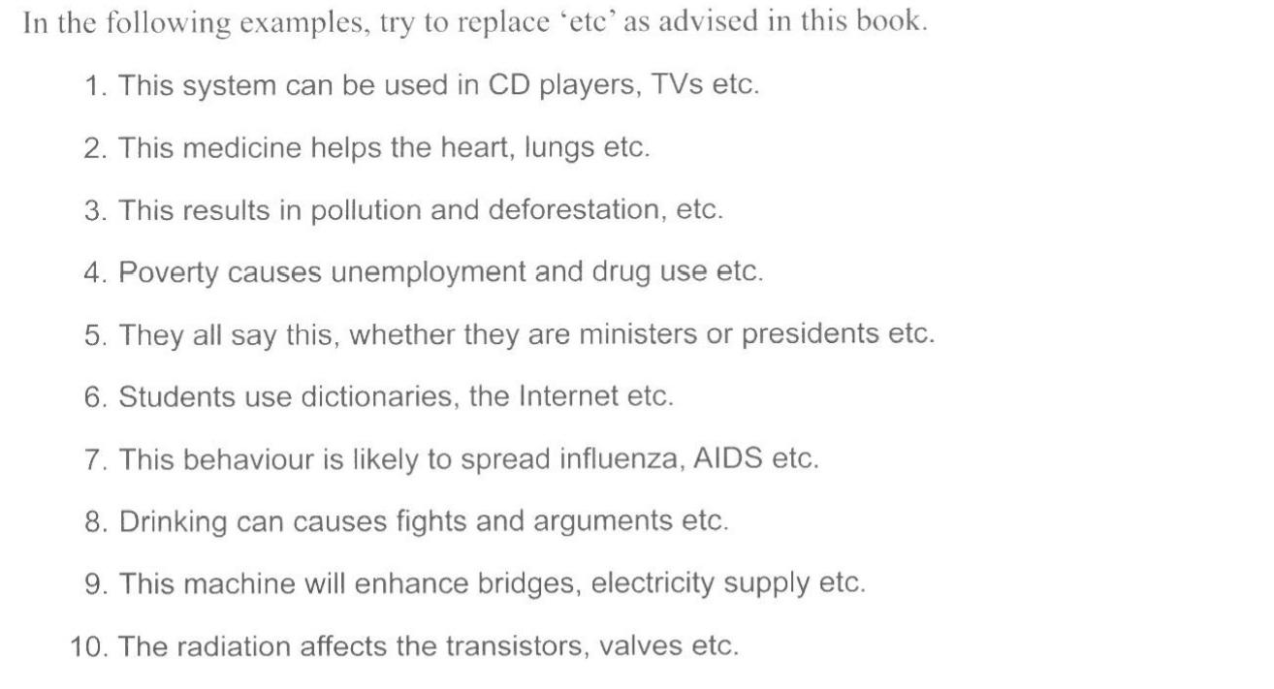

* 1. **Use the more appropriate formal negative forms.**

**Not...any= no**

**Not...much = little**

**Not...many= few**

**Not necessary= unnecessary**

**Not an easy question= an uneasy question / no easy a question/ a difficult question**

E.g.

- the analysis *didn’t* yield *any* new results.= the analysis yielded *no* new results

- the government didn’t allocate much funding for the program – ....

- the problem doesn’t have many viable solutions - .....

* 1. **Limit the use of direct questions.**
* What can be done to lower the cost?

+ we now need to consider what can be done to lower the cost. / we now need to consider how costs may be lowered.

* 1. **Place adverbs within the verb.**

Adverbs often are placed **midposition** rather than in initial or final positions.

* *Then* the solution can be discarded – the solution can *then* be dicarded.
* The blood is withdrawn *slowly* – the blood is *slowly* withdrawn.
  1. **Use “this + summary word”**

**Use “this + summary word”**

1. ESL lectures know that students need to understand the differences between formal and informal language. However, this.....................cannot usually be acquired quickly.
2. In recent years, the number of students applying to Ph.D programs has increased steadily,while the number of places available has remained constant. This................... has resulted in intense competition for admission.
3. According to a recent survey, 26% of all Americn adults, down from 38% thirty years ago, now smoke. This...................can be partly attributed to the mounting evidence linking smoking and fatal diseases such as cancer.
4. Early in September each year, the population of Ann Arbor, Michigan, suddenly increases by about 20,000 as students arrive for the new academic year.This...............changes the character of the town in a number ways.
5. Nowadays, laptop computers are lighter, more powerful, and easier to use than they were five years ago. These..................have led to an increase in the sales of these machines.
6. In the united States, the level of lead, carbon monoxide, and sulfur dioxide have fallen between 1978 and 1987. Despite this........................,the air is still contaminated by many carcinogens.
7. Ozone levels in the United states increased 5% from 1986-87, another 15% from 1987-88, and an additional 10% from 1988-90. Environmental Protection Agency (EPA) officials are concerned that if this.............................continues, serious environmental damage may occur.
8. The EPA has revealed that 20 of 320 known toxic chemicals in the air probably cause more than 2,000 cases of cancer annually. While this...........................may not seem high, it is still a cause for concern.
9. The EPA states that individuals living near chemical plants have a higher than normal chance of developing cancer. This........................has been substantiated by numerous studies.
10. The chemical manufacturers Association has decided it will more strongly support the pollution control efforts of the EPA. This ..............................was a major factor in the drafting of new regulatons.
11. Lawmakers in southern California are proposinf banning the sale of new charcoal grills, requiring sophisticated pollution control devices, and demanding that by the next century 40% of all cars and buses run on clean fuel, such as methanol. These .........................may indeed become law in the near future.
12. A study of 7000 recovering alcoholics showed that 3% were under age 20 and 18% were between 21 and 30. Moreover, the study revelaed that the average age of alcoholics seems to be falling. This ..............................worries health officilas. In the past, alcohol addictions was considered a social problem closely related to criminal or immoral behavior. However, today this .................................is no longer widely held. Many alcoholics have lived through difficult childhoods, divorces, and professional disappointment. Even so, these...............................are not good predictors of who will become an alcoholic. In a recent study, children of alcoholics were found to be four times as likely as children of nonalcoholics to be alcoholics – even when raised by non-alcoholic parents. This ........................has led reserchers to believe there is a genetic link in alcoholism.

**12.Avoid addressing the reader as “you” / we**

- **You** can see the results in any aspect of the economy

- the result can be seen in any aspect of the economy.

EXERCISE

Reduce the informality of each sentencer.

1. If you fail the exam, you can’t enter the university.
2. Ok, what are the causes of deformation? Many possibilities.
3. You can clearly see the difference between these two process.
4. A small bit of ammonium dichromate is added to the gelatin solution gradually.
5. These special tax laws have been enacted in six states: Illinois, Iowa, Ohio,etc.
6. The subjects didn’t have much difficulty with the task.

* 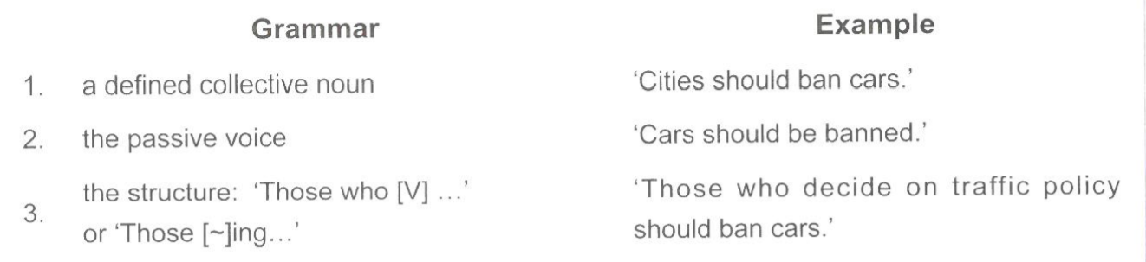

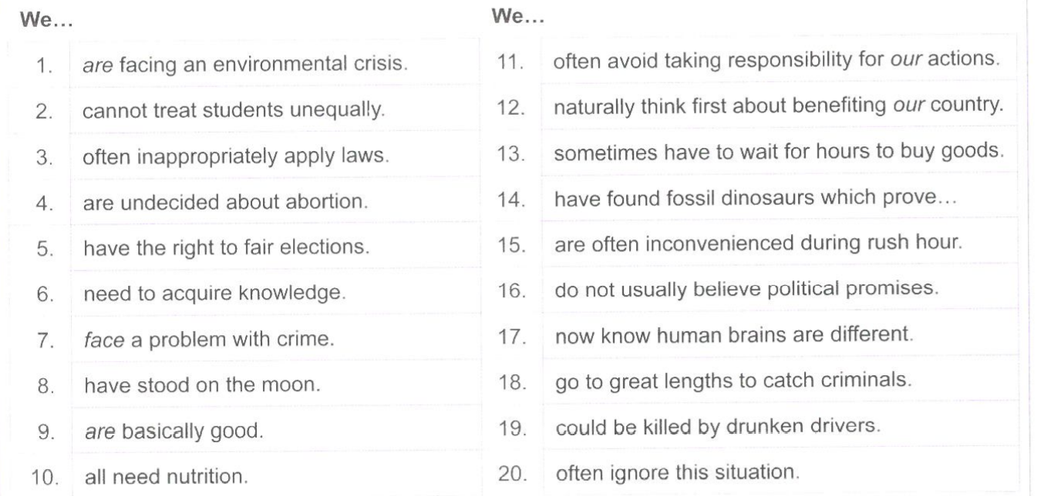

**LAST ADVICE**

* read and listen to as many materials as you can that cover these topics – and build your phrasebook as you do. There are numerous online sources of relevant reading material out there. Some of the ones that I’ve found particularly useful for those preparing for IELTS include:
* [Breaking News English](https://breakingnewsenglish.com/) This website is fantastic for all levels of language learners – you’ll find articles about current events written in multiple levels of difficulty.  
  [BBC World News](http://www.bbc.com/) (world news and current events)  
  [The Economist Daily Chart](https://www.economist.com/blogs/graphicdetail) (data journalism, in charts, maps, infographics and interactive-data features)
* [Improving your listening skills](https://www.ieltspodcast.com/listening/031-a-little-trick-examiners-do-in-the-ielts-listening-exam/) is another way, and a much more natural way to build vocabulary.  
  [BBC Earth](http://www.bbc.com/earth/world) (nature, environment, human interest and animals)
* Don’t limit yourself to just these sources though – there are a lot more out there – finding something that interests you is the most important thing to do.
* If you are reading material regularly, and add 10-15 new words and phrases to your notebook regularly, over time you will build your own reference book that you can use to study and remember the “new” words until they are no longer new!